How to Register for CPCC courses Through MyCollege

- Go to www.CPCC.edu
- Click Current Students at the top right of the screen
- Click on MyCollege center of the screen
- Click Log In and log into your account
  - Sign In using your CPCC username and password
- Click Student Planning
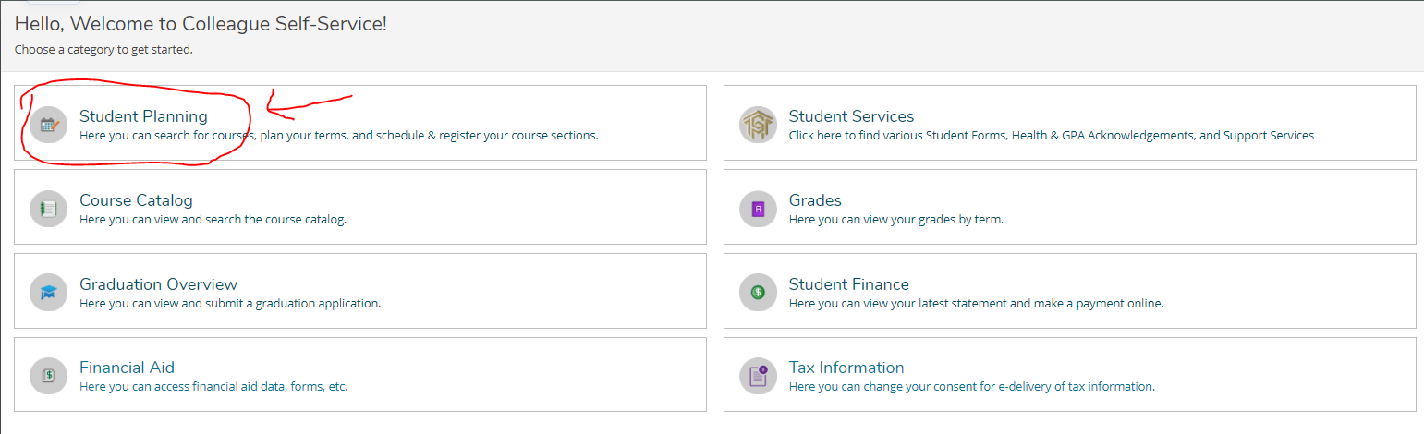
- Click Plan your Degree & Register for Classes on the right side of the screen
  - Note: Below the Plan your Degree and Schedule your courses – See the three tabs (Schedule Timeline Advising)
  - Notice Summer 2021 – Click the arrow to the left of Summer 2021 and move to Fall 2021

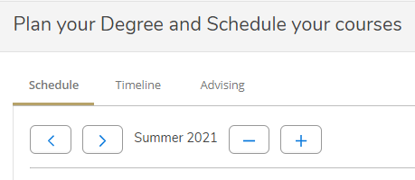
- In the Search for courses box near the top right of your screen, type the class you want to take (use the following link – type in https://www.cpcc.edu/programs/dual-enrollment in your browser if the hyperlink does not open – to see the list of classes for your approved pathway and select the pathway you chose per discussion with Ms. Snipes)
  - Scroll down to Program Options: Dual Enrollment Pathways
  - Click on the appropriate pathway for the list of courses
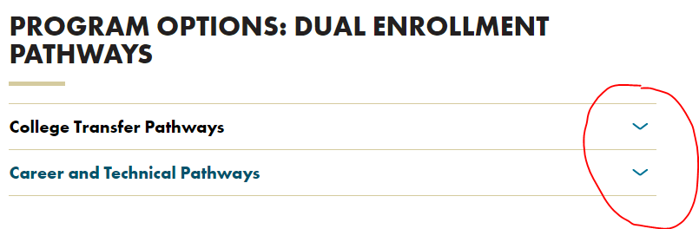
  - You are allowed to either register for 1 or 2 courses for the Fall semester only at this time
  - Once you have identified the correct class, return to the Plan your Degree & Register for Classes page and enter the name into the Search for courses box (ex., ENG 111)
- A list of courses will populate on your screen. On the left side, you will see Filter Results. To find the classes offered that works for your South Meck schedule, you need to filter by Availability (open sections only), Locations, and Terms (Fall 2021). The 3 I listed are the most commonly used.
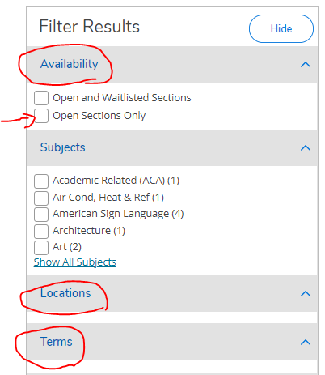

  - When you filter locations, the locations closest to South Meck are Harper, Levine and Central campuses. If you prefer online courses, select “other off campus”.
- Click View Available Sections for... under the heading for the class you just searched
- Scroll through and find one that works with your South Meck schedule then click the blue button to the right that says Add Section to Schedule.
  - Be sure to click the one directly to the right of the section you want to add, not the one below. If there are 0 seats in the class, you cannot select this section.
  - Pay attention to the Beginning date and End date for your class
  - Pay attention to the Start time and End time for the course
  - Other Off Campus courses are online courses and do not have a Start time or End time
- A new window will pop up that may give some yellow warnings. As long as they are yellow, you can ignore these. This lets students know the pre-requisites for the class. The pre-requisites do not apply to you.
- Click Add Section
- You will continue to search for all your classes in this way and add them to your schedule
- Once you have added all the classes you want, click Back to Plan and Schedule located near the top left of the screen.
  - Note: If you do not see Back to Plan and Schedule, then click Academics > Student Planning > Plan your Degree & Register for Classes > Notice Summer 2021 – Click the arrow to the left of Summer 2021 and move to Fall 2021
  - You should see your courses selected
- Review your selections, make sure they work with your South Meck schedule for either 3rd & 4th blocks (Seniors are allowed to take 2 courses if their SM schedules have the available times) and (Juniors are allowed to take one course for their 4th block only)
- Then click Register Now to register for all classes in your plan. Once registration is complete, the boxes on the calendar will turn green and the boxes on the left will say registered but not started.
Note: If you have any problems with registration while I am away for my summer break, then please contact CPCC at ccp@cpcc.edu.

I will return to my office on August 1, 2021. Stay Safe and enjoy your summer!

